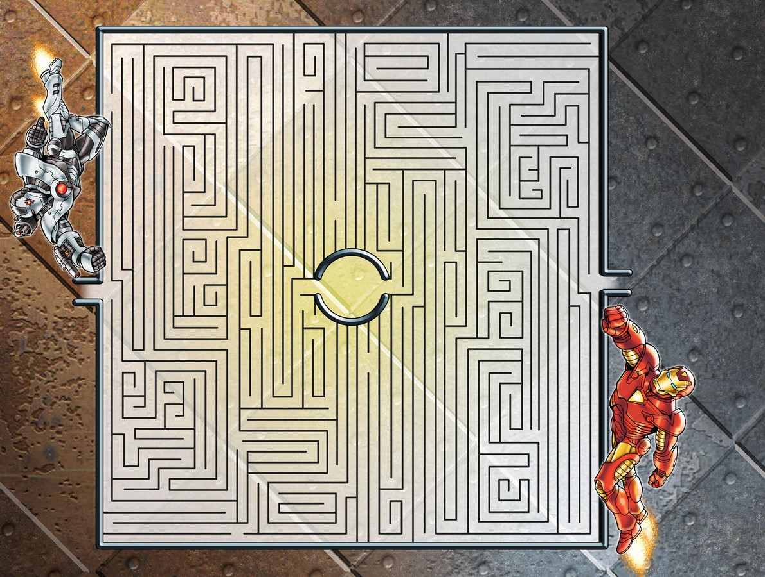

User Manual Version 1.0

Maze and men

Maze and men

Game pLay Instruction

Introduction

“Mazes and Men” is designed in C programming language using curses library. In this game, a player needs to solve the maze within a certain timeframe to face an enemy with a different power. The player will roll three six-sided dice to fight against the enemy. If the sum of those three dice is greater than or equal to the level of the enemy, the player wins that round and advance to the next level. The player needs to win ten levels to win the game. This game is basically made using structures and 2D arrays. The curses library is really what allows this game to work. The IDE used for this game is Codeblocks and Nano on Raspberry Pi.